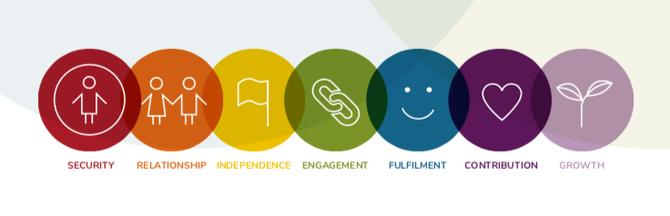

THE FLOURISH MODEL
and the History of Global Wellbeing Indicators
Wendy Ellyatt
Putting People at the core
Across the world people have been exploring ways in which we can better measure development and progress in terms of human wellbeing. A number of challenges have arisen in the approaches undertaken by different countries and cultures, but there has been clear agreement that measures of GDP alone are not sufficient and that we need to develop a more coherent global approach. There has also been clear agreement that the current systems are failing to appropriately support the development of flourishing communities and an equitable, sustainable and stable planet. The Flourish Model suggests a new ‘Ecology of Wellbeing’ that puts lives of meaning, purpose and value back at the core and the natural, healthy development of young children as fundamental to the process.
__________________________________________________________________________________
The need to more clearly define and measure human wellbeing has thrown up some very interesting cultural challenges. It has revealed that, despite being members of the same species, our different cultures and backgrounds have resulted in very different ideas about what a ‘Good Life’ looks like. In Western society it has become increasingly associated with material wellbeing and competitive success of the individual, whereas in other areas of the world it is more about ways of living meaningfully, sustainably and in alignment with the natural world.
As ever, what we are really seeking is a sensible balance between the two.

MEASURING WELLBEING - THE HISTORY
Way back in 1968 Robert Kennedy made the following statement:
“The gross national product does not allow for the health of our children, the quality of their education or the joy of their play. It does not include the beauty of our poetry or the strength of our marriages, the intelligence of our public debate or the integrity of our public officials. It measures neither our wit nor our courage, neither our wisdom nor our learning, neither our compassion nor our devotion to our country, it measures everything in short, except that which makes life worthwhile.”
The human development approach is anchored in Nobel laureate Amartya Sen’s work on human capabilities, framed in terms of whether people are able to “be” and “do” desirable things in life. Examples include

Beings: safe, well fed, sheltered, healthy
Doings: work, education, voting, participating in community life.
As the United Nations Development Programme says:
“Freedom of choice is central to the approach: someone choosing to be hungry (during a religious fast say) is quite different to someone who is hungry because they cannot afford to buy food…Gross Domestic Product (GDP) and economic growth emerged as leading indicator of national progress in many countries, yet GDP was never intended to be used as a measure of wellbeing.”
In collaboration with political philosopher Martha Nussbaum, development economist Sudhir Anand and economic theorist James Foster, Sen helped to make the capabilities approach predominant as a paradigm for policy debate in human development and in 2004 launched The Human Development and Capability Association. Amongst other things the Association stressed the importance of ‘agency’ as being about people being able to define their own levels of wellbeing and achievement in relation to their personal values and goals within the context of wider society. Concern for agency stresses that ‘having a voice’ as in public debate, participation and democratic decision-making is an essential element of human rights and freedoms.
Until the 1990s, however, GDP remained the most talked about and implemented measure of economic performance and social progress. This was despite the increasing levels of disquiet about an over-focus on the success of the individual, the goal of achieving ever-increasing profits no matter what the human or ecological cost and the indisputable observation that there is much more to life than economics and material goods
In 1990, the first Human Development Report sought to develop the World Banks’ own focus on the issue through the introduction of the Human Development Index (HDI). This suggested three key wellbeing outcomes: health (measured as longevity), income (standard of living) and education (literacy).
But it took until 2009 before there was a real step forward. In February 2008, the President of the French Republic, Nicholas Sarkozy, unsatisfied with the present state of statistical information about the economy and the society, asked the economist Joseph Stiglitz, Amartya Sen and Jean Paul Fitoussi to create a Commission, subsequently called “The Commission on the Measurement of Economic Performance and Social Progress” (CMEPSP). The Commission’s aim was to identify the limits of GDP as an indicator of economic performance and social progress, including the problems with its measurement; to consider what additional information might be required for the production of more relevant indicators of social progress; to assess the feasibility of alternative measurement tools, and to discuss how to present the statistical information in an appropriate way.
Published in 2009, the report persuasively argued that GDP was no longer an effective indicator of whether societies were progressing - in the sense of becoming healthier and better places for citizens to live - and that the benefits of a growing economy were not democratically accessible to all members of society. One of the main recommendations of the Report was to “shift emphasis from measuring economic production to measuring people’s well-being.” This then led to an explosion of political and academic attempts to better ‘measure what matters’. Critically the Report acknowledged that in any assessment of progress it was important to incorporate measures of both objective and subjective wellbeing.
Initiatives were subsequently launched across the globe to find ways of doing this, but there were basic differences of opinion about what wellbeing means and how you effectively measure it. In

2013, Martine Durand, Chief Statistician of the OECD stated that, “We are witnessing a convergence in our understanding of well-being with a common core set of well-being dimensions, and national priorities reflected in more specific domains and measures.” However subjective wellbeing remained difficult and confusing to measure with statisticians constantly frustrated with different frameworks and diverse datasets.
Not only this but different cultures were calling for measures that reflected their own worldviews and indigenous communities were at the forefront of challenging measures that failed to take into account the interconnectedness of all life. They argued for a more ‘wisdom-based approach’, suggesting that without the balancing nature of wisdom knowledge alone could be a destructive and dangerous force. Wisdom takes a ‘whole-system’ perspective and looks at knowledge only in terms of how effectively it serves the whole. For them an essential characteristic of wellbeing was the integration and sharing of authentic lived experience. Science now concurs that human consciousness transcends many of the barriers that we thought existed and that we are more deeply connected, to both others and the larger world, than we have been led to believe. The indigenous perspective says that in championing a rational and separatist worldview we may have gained material prosperity, but lost something vital about the meaning of our existence.
Latin America was another area of the world calling for the development and promotion of new ways of thinking about how to measure development and progress. Both Bolivia and Ecuador have been developing initiatives based on the notion of ‘Buen Vivir’ – ‘a ‘good life’ or ‘living well with nature’. According to the Andean culture’s world view, the final objective of human activity is not power or money accumulation, but the nurturing of a tender, harmonious and vigorous life – a ‘Sumaq Kawsay’ both for humanity and Mother Earth: the ‘Pachamama.’
In Japan the concept of ‘Ikigai’ is used to indicate the source of value in one's life or the things that make one's life worthwhile. The word translated roughly means "thing that you live for" or "the reason for which you wake up in the morning” Each individual's ikigai is personal to them and specific to their lives, values and beliefs. It reflects the inner self of an individual and expresses that faithfully, while simultaneously creating a mental state in which the individual feels at ease. Activities that allow one to feel ikigai are never forced on an individual; they are often spontaneous, and always undertaken willingly, giving the individual satisfaction and a sense of meaning to life.
And in South Africa the term ‘Ubuntu’ was a Zulu world meaning "humanity". It is often translated as "I am because we are," and also "humanity towards others", but is often used in a more philosophical sense to mean "the belief in a universal bond of sharing that connects all humanity".
A burgeoning scientific interest in complexity theory and natural systems design also confirmed the indigenous view that all living things are interconnected. This showed us that a living system has permeable boundaries and takes in, and responds to, information from the environment. Through cognition and self-organisation it is able to constantly adapt and change In order to do so it must, however, remain open to possibility. Closed systems prohibit the vital ‘reaching out into novelty’ that is an essential element in life’s adaptive capacity.
The challenge therefore became how to create a universal Human Wellbeing framework and methodology that could be used to better understand the foundations of wellbeing and to identify the key areas that needed to be taken into account in order to maximise individual and collective human flourishing. Such a model would need to highlight and promote the complementary relationships and moral responsibilities of parents, families, carers, schools, workplaces, local authorities, governments and wider society to defend and protect the rights and freedoms of

children and to ensure that all civic policies have the best interests of the child at their heart. It would also need to encourage a shift of emphasis from production-oriented measurement systems to those focused on the well-being of current and future generations, i.e. toward broader and more balanced measures of social progress.
In 2008 Bhutan developed its own concept of Gross National Happiness (GNH), based upon the Buddhist principles of good living. And in 2011, The UN General Assembly passed the Resolution "Happiness: towards a holistic approach to development" urging member nations to follow the example of Bhutan and measure happiness and well-being and calling happiness a "fundamental human goal."^{[5]}
In 2011 the OECD started to take a more leading role with its ‘Better Life’ Initiative. A second ‘How’s Life?’ Report was then published in 2013, giving a detailed analysis of the performance of 28 countries in terms of the ‘How’s Life?’ indicators. The framework was a direct descendant of the Sarkozy Report but multiplied the number of dimensions under three ‘pillars’ for understanding and measuring wellbeing i.e. Material Living Conditions, Quality of Life and Sustainability with the latter referring to four types of ‘capital’: financial, social, natural and human.
The UK’s Office for National Statistics (ONS) then launched the 2011 ‘Measuring What Matters’ Consultation on Nation Wellbeing using the following questions: What is national well-being? What matters? How can it be measured? Who will use the measures and for what? The debate ran for 5 months with 175 events around the country attended by over 7,000 people. It generated over 34,000 responses from online forums and other channels. Ultimately it concluded that what mattered most to people was: Health, Relationships, Work, The Environment, Education and training - with the common underlying themes of fairness and equality. It then proposed 10 domains of wellbeing with 3-5 headline measure each: Personal Wellbeing, Our Relationships, Health, What we Do, Where we Live, Personal Finance, The Economy, Education and Skills, Governance and The Environment.
“If you are serious about measuring wellbeing, the measures and indicators need to be meaningful and make sense to ordinary people and they need to lead to action/change. No point in having a measure for its own sake” ONS, 2011
Since then the survey has been run every year with the measures including both objective data (for example, healthy life expectancy) and subjective data (for example, satisfaction with health) in order to provide a more complete view of the nation than measures such as Gross Domestic Product (GDP) can do alone. Change over time is assessed in terms of whether measures have improved, deteriorated or shown no overall change, covering the latest year for which data are available and the previous 3 years.

A closer look at the sustainability of national well-being for the future is taken using ONS valuation of stocks of things like education, natural resources and community cohesion, known as “capitals”. The data has been expressed in a number of ways such as the UK Wellbeing ‘Wheel’.

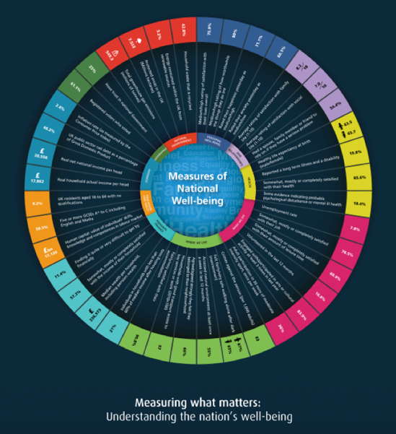

Figure 1 – ONS Wellbeing Wheel, 2018
It has also started to produce separate datasets on child wellbeing using a set of 31 headline indicators. The measures include objective data (for example, participated in sport in the last week) and subjective data (such as happiness with appearance). The aim is to provide a holistic view of life in the UK for children reflecting both the circumstances of their lives and their own perspectives. To provide an overview of if and how quality of life is improving for children in the UK, it assesses whether each indicator has improved, deteriorated or remained unchanged. It is, however, currently in the process of reviewing its children’s well-being indicators and how it publishes the data.
Following his own interest in researching the ‘Economics of Happiness’ Lord Richard Layard launched the UK-based organisation Action for Happiness, which currently has the Dalai Lama as its patron. This was then followed by increasing political interest in the concept of Mindfulness, with the All Party Parliamentary Report ‘Mindful Nation’ produced by Jon Kabat-Zinn in 2015.
Over a period of six months, the Bellagio Initiative was implemented by the Institute of Development Studies, Resource Alliance and the Rockefeller Foundation as a process of deliberation about how to meet the challenges to and seize the opportunities for protecting and promoting human wellbeing in the twenty-first century. It consisted of a series of global events that engaged a wide range of policymakers, academics and practitioners from international development and philanthropy. There were three components to the Bellagio Initiative: 1. a series of Commissioned Papers that explored key challenges and opportunities for international development and philanthropy organisations; 2. Global Dialogue meetings attended by a wide spectrum of participants at a range of locations worldwide; 3. a two-week Summit held at the Rockefeller Foundation conference centre in Bellagio, Italy, in November 2011. The 2012 Report ‘Promoting Human Wellbeing in a Challenging Global Context’ recognized the plurality of global thinking and approaches and the need for a more ‘people-centred’ ecosystem approach:
“Throughout the various meetings in the process there have been repeated calls for a more people-centred approach to development, supported by the human wellbeing focus. In all attempts to graphically represent the ecosystem, it stimulated the question – where are the people? The proposition that arises from the adoption of the human wellbeing focus is that, in further development of the new international development ecosystem, it will be important to keep the human beings who are intended to be the beneficiaries of that effort at the centre of the picture”
With Richard Layard as one of the editors, the first World Happiness Report - Well-being and Happiness: Defining a New Economic Paradigm was released on April 1, 2012 as a foundational text for the United Nations (UN) and drew international attention. The report outlined the state of world happiness, the underlying causes and challenges and the policy implications highlighted by case studies. In 2013, the second World Happiness Report was issued, and since then has been issued on an annual basis with the exception of 2014.
In the reports, experts in the fields of economics, social psychology, statistics and data analysis described how measurements of wellbeing could be used more effectively to assess the progress of nations. The World Happiness Report 2018 ranked 156 countries by their happiness levels, and 117 countries by the happiness of their immigrants. The main focus of the year’s report, in addition to its usual ranking of the levels and changes in happiness around the world, is on migration within and between countries. Four different countries have held the top spot in the last four reports: Denmark, Switzerland, Norway and now Finland.
All the top countries tend to have high values for all six of the key variables that have been found to support well-being: income, healthy life expectancy, social support, freedom, trust and generosity.
At the same time, following an extensive ten-year extensive nationwide consultation, the citizen-driven Canadian Index of Well-being (CIW) was launched as a ‘companion model’ to GDP. The index is composed of eight interconnected domains that measured stability and change in the wellbeing of Canadians over time i.e. Community Vitality, Democratic Engagement, Education, Environment, Healthy Populations, Leisure and Culture, Living Standards, and Time Use - and within these a further 64 indicators. The CIW describes wellbeing as, “The presence of the highest possible quality of life in its full breadth of expression, focused on but not necessarily exclusive to: good living, standards, robust health, a sustainable environment, vital communities, an educated populace, balanced time use, high levels of democratic participation, and access to and participation in leisure and culture”.
In 2013, as Thinker in Residence, the American psychologist Professor Martin Seligman challenged South Australia to position itself as a world-leading State of Wellbeing. The challenge was responded to through the ‘State of Wellbeing’ Project undertaken by the Department for Health and Ageing (DHA) in collaboration with the Department of Communities and Social Inclusion (DCSI) and the Office for Public Sector Reform. The aim of the 90 Day Project was to draw together key stakeholders to contribute to the development of an agreed description and position on wellbeing in the South Australian context. To help inform this work, a survey was undertaken to capture the views of everyday citizens around what contributes towards wellbeing. The survey, ultimately with 540 responses, asked respondents to identify factors that they considered contributed most to wellbeing, at three levels - Personal, Family/Community and State Population level. 540 people responded.
A statement was subsequently made by the Premier of South Australia, the Hon Jay Weatherill M.P., at the International Positive Psychology Conference held in Adelaide on 23 September, 2016. It recognised that for South Australia to be a State of Wellbeing there was a need to be clear about:
• What we mean by wellbeing (i.e. a wellbeing description or definition);
• What contributes to wellbeing (i.e. a framework of wellbeing determinants); and
• How we could best measure the impact of our wellbeing efforts?

With the next step being to consider these questions, and work towards a South Australian measurement of wellbeing.
In his book Flourish, Seligman concludes that there are five elements to wellbeing that he terms PERMA:
- Positive emotion—Can only be assessed subjectively
- Engagement— An energetic ‘flow-state’ that, like positive emotion, can only be measured through subjective means.
- Relationships—The presence of friends, family and intimate others
- Meaning—Belonging to and serving something bigger than one's self
- Achievement—An intrinsic sense of accomplishment that is sought even when it brings no positive emotion, no meaning, and nothing in the way of positive relationships.
"Each element of well-being must itself have three properties to count as an element:
- It contributes to well-being.
- Many people pursue it for its own sake, not merely to get any of the other elements.
- It is defined and measured independently of the other elements."
A number of non-governmental organisations also started to contribute to the dialogue. In Scotland OXFAM developed the Humankind Index as a policy assessment tool which people themselves could use to assess the wellbeing impacts of various economic and social policy options. This particularly sought to give voice to more excluded elements of society.
The Swiss based Jacobs Foundation produced the 2013 Children’s Worlds Survey that gathered subjective data from over 53,000 children aged around 8, 10 and 12 years old in 15 countries across four continents on how children spend their time and how they feel about their lives. What was clear from the report was the need to increasingly engage children as young citizens and stakeholders with the right to participate in decisions that impacted their own lives and to question why, according to where they lived, children had very different responses to the questions asked.
The Skoll Foundation worked with leading scholars in the US to develop the ‘Social Progress Index’ which defines social progress as “the capacity of a society to meet the basic human needs of its citizens, establish the building blocks that allow citizens and communities to enhance and sustain the quality of their lives, and create the conditions for all individuals to reach their full potential”. Rather than emphasizing traditional measurements of success like income and investment, they measure 50 indicators of social and environmental outcomes to create a clearer picture of what life is really like for everyday people. They then divide these indicators across three broad dimensions of social progress: Basic Human Needs, Foundations of Wellbeing, and Opportunity.

“Ultimately, the goal of the Social Progress Imperative is to empower leaders and change-makers from business, government, and civil society by providing them with the data they need to understand where their actions will have the greatest impact”.
In 2014 The Legatum Institute, a private think-tank, initiated ‘The Commission on Wellbeing and Policy’ which was Chaired by former UK Cabinet Secretary Lord O’Donnell and included the participation of Richard Layard. The Commission, which ran for approximately one year, produced

a final report that illustrates the strengths and limitations of wellbeing analysis and provides original and authoritative guidance on the implications for public policy. It considered three main measures:
• How do you feel (i.e. how happy are you)?
• How do you evaluate your life (i.e. how satisfied are you with your life)?
• Do you feel your life is worthwhile

The report concluded:
“Designing policies to enhance social and personal wellbeing is a new field, but the innovation of basing appraisal on changes in wellbeing, rather than income, is spreading rapidly… We should treat citizens with respect and empower them more. Our final recommendation in this report is simple: we should measure wellbeing more often and do so comprehensively, making the data accessible. This would help governments improve policies, companies raise productivity, and people live more satisfying lives.”
And as far back as 2006 The UK-based Children’s Society launched its annual ‘Good Childhood Report’ as the first independent report into the state of childhood. “There can be no doubt that the childhood experienced by today’s children is significantly different from that of previous generations. While incomes in the United Kingdom have doubled in the last 50 years, research shows that the well-being of children in the UK is rated among the worst in Europe.” The latest report reveals the devastating impact that multiple disadvantage can have on how children feel about their lives. It shows that children and young people’s happiness with their life as a whole is at its lowest since 2010 and children facing seven or more of the 27 serious problems were 10 times more likely to be unhappy than those with none.
What became increasingly clear to everyone involved over that time was that too many of the old measures of development had little to do with people’s lived experience and that measures of development and progress needed to bring people back into focus at the centre of policy debates and deliberations. Subjective wellbeing is an essential element of the process and understanding the foundations of wellbeing is vital if we are to initiate positive cultural change.

We are only now seeing consistent instances of the systemic collection of subjective wellbeing data, but the frameworks and methodologies remain diverse and challenging to consolidate and accurately interpret. Public policy thinking in both developed and developing countries have too often remained dominated by ‘top-down’ theories of social and economic development and these have perpetuated the very limiting criteria through which we have been measuring social progress.
The importance of lived experience means that we need to find out what really matters to people and a prime mover in this area has been the author Richard Barrett with his interest in how to initiate positive cultural evolution in business and society. In the mid 1990s Barrett developed his Seven Levels of Consciousness® Model as a further development of Maslow’s hierarchy of needs. The model suggested that, whether as individuals, organisations or nations, we operate at levels of consciousness and we grow in stages of psychological development.
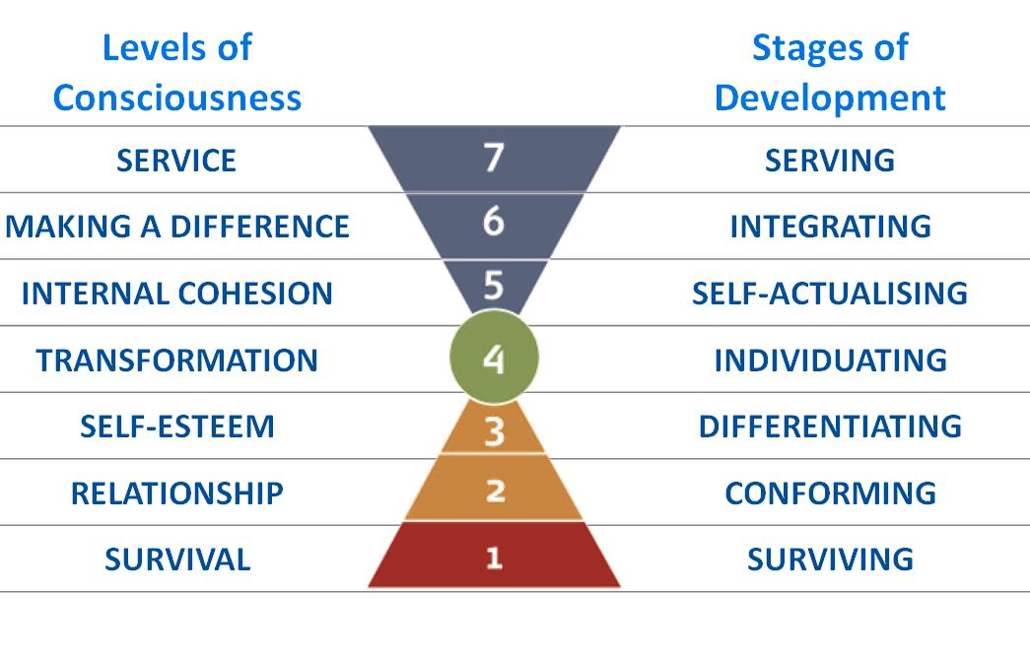
Figure 2: Barrett Values Centre, 2018
Through the Barrett Values Centre he then further developed the model into a series of values mapping instruments known as the Cultural Transformation Tools. He also introduced the concept of the Seven Levels of Leadership Consciousness. Barrett believed that the well-being of any nation was significantly influenced by the needs that are uppermost in the minds of its citizens. Understanding these needs was, therefore, vitally important for building successful, harmonious, and peaceful nations. “Whatever people say they need is what they value and - Nations prosper or fail to the degree that they build social capital”.

To-date the centre has carried out more than thirty national assessments with 450,000 people worldwide completing their own Personal Values Assessment (PVAs). When consolidated these have revealed the following top ten values of humanity.
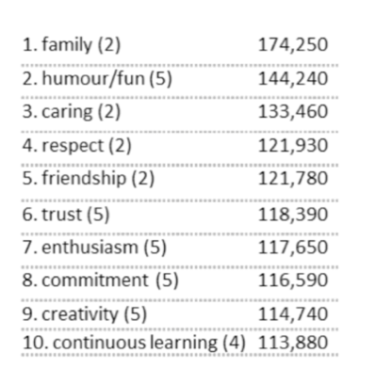
These present what could be a very hopeful view for the future and it is interesting to reflect whether the systems that people are currently living in are a reflection of these values and, if not, how this is impacting on their ability to flourish.
THE FOUNDATIONS OF WELLBEING
Throughout most of these enquiries into the measurement of wellbeing what was notably absent was an equal enquiry into the foundations of what shapes and underpins it. Fortunately, over the last decade the new Science of Child Development has been coming to the fore, with the Harvard Centre for the Developing Child acting as a key catalyst. The Canadian Human Early Learning Partnership (HELP) has also stated to look more closely at the child within the context of his or her local environment. Both are multi-disciplinary collaborations designed to bring an understanding of biological, neuro-physiological and psychological development to bear on all public decision- making. Drawing on the best international thinking and research, and employing a rigorous and evidence-based approach, they have been seeking to identify how best to support early learning and development in a manner that enabled every child to flourish and to fulfil his or her full potential.
What the science has shown us is that every person has a unique genetic make-up that predisposes him or her to meaning-make in different ways and to be interested in different things. Each person has different pre-dispositions, intelligences, strengths and capacities. And each person perceives and experiences the world in different ways. This is really important as the world needs people with different skills and abilities. The environments that we come from and find ourselves in really do matter and help shape who we become.
Although human minds are shaped through the experiences and relationships that come through living in a social world, they also have a deep connection to the natural environments within which they have evolved, and this is consistent with what many indigenous cultures have been telling us. Young children have an innate connection with, and empathy for, the natural world that is evident from the earliest years. One of the most striking changes in children’s lives over the past century is the erosion of the time spent in nature and it is becoming clear that this may be having a profound impact, not only on child health and wellbeing, but on their environmental understanding and attitudes in later life. Children’s spirits are actively nourished by the natural world and there is increasing recognition that spirituality is something innate that lies deeper than any subsequent cultural overlays of belief and religion.
The basic architecture of our brains is constructed through an ongoing process that begins before birth and continues into adulthood. In the first few years of life, more than one million new neural connections are formed every second.After this period of rapid proliferation, connections are reduced through a process called pruning, so that brain circuits become more efficient. Sensory pathways like those for basic vision and hearing are the first to develop, followed by early language skills and higher cognitive functions. Connections proliferate and prune in a prescribed order, with later, more complex brain circuits built upon earlier, simpler circuits. Socioeconomic disadvantage and stress in early childhood is associated with striking differences in cognitive structure and function during a time when dramatic changes are occurring in the brain. It is becoming increasingly apparent that children living in poverty, or in materially sufficient but emotionally deprived circumstances, may see delayed or diminished development of their language, memory, and executive functions. In other words, diminished life experiences literally result in diminished and less effective brain architecture. ​​Their ability to respond to, and recover from, adversity is also compromised, reinforcing the understanding that resilient children are made, not born.
We have each been designed to constantly learn and grow and to find ways of expressing our own unique identity and potential within a world of others who are also striving to do the same. Through our genetic codes we also carry forward biological memories that are both individually different and commonly shared. We all, therefore develop mindsets and dispositions that are uniquely configured to our own biology and the experiences that we have within our own environments. Strong, loving and consistent early relationships, particularly that of parents, but also through high quality early caregivers, can really help to combat the impact of poverty.
Governments are increasingly investing in early intervention schemes targeted at disadvantaged families and children, but we urgently need to explore why so many people are living in poverty and what we can do to improve basic living conditions. Mother-infant bonds and parenting skills really matter, but reducing inequality and better understanding the reasons behind social deprivation are key to solving the problem.
We now know that Adverse Childhood Experiences (ACES) are the single biggest predictor for later problems in adult health and wellbeing and there is enormous global interest in how to protect our youngest children from undue levels of stress. In recent years the Nobel Laureate James Heckman has become an increasingly active voice in highlighting the significant economic and human benefits of investing in the early years. As he says:
“The rate of return for investment in quality early education for disadvantaged children is 7-10% per annum through better outcomes in education, health, sociability, economic productivity and reduced crime”.
In 2013, The Wave Trust, in collaboration with the UK’s Department of Education (DfE) produced the Conception to Age 2- Age of Opportunity Report that asked the question - How advisable is it for national or local policy-making bodies in the UK, with responsibility for child health or welfare, and control over spending, to switch investment more heavily to the early years? It concluded:
“The short answer is there is general expert consensus that it is somewhere between economically worthwhile and imperative to invest more heavily, as a proportion of both local and national spend, in the very earliest months and years of life.”
Nine approaches to evaluating the outcomes of early years’ investment were reviewed by the report with the following findings:
- Every approach – even the most cautious and circumspect in its recommendations – found that returns on investment on well-designed early years’ interventions significantly exceeded their costs.
- The benefits ranged from 75% to over 1,000% higher than costs, with rates of return on investment significantly and repeatedly shown to be higher than those obtained from most public and private investments.
- Where a whole country has adopted a policy of investment in early years’ prevention, the returns are not merely financial but in strikingly better health for the whole population. The benefits span lower infant mortality at birth through to reduced heart, liver and lung disease in middle-age.
- The logical links between the investments and the health benefits are described in the ‘Adverse Childhood Experiences’ (ACE) studies which reveal that for every 100 cases of child abuse society can expect to pay in middle or old age for (amongst a wide range of physical and mental health consequences):
one additional case of liver disease
two additional cases of lung disease
six additional cases of serious heart disease and
16% higher rate of anti-depressant prescriptions (Felitti and Anda, 2009)
None of the estimates fully took account of the additional economic value of the knock-on effect that child abuse averted in one generation will itself result in a cumulative reduction in this dysfunction during future generations.
In 2017 the NSPCC calculated that the estimated average lifetime cost of non-fatal child maltreatment by a primary care-giver was £89,390 (with a 95% certainty that the costs fall between £44,896 and £145, 508).
And in the USA an influential 2012 report concluded that:
The estimated average lifetime cost per victim of nonfatal child maltreatment is $210,012 in 2010 dollars, including $32,648 in childhood health care costs; $10,530 in adult medical costs; $144,360 in productivity losses; $7,728 in child welfare costs; $6,747 in criminal justice costs; and $7,999 in special education costs. The estimated average lifetime cost per death is $1,272,900, including $14,100 in medical costs and $1,258,800 in productivity losses. The total lifetime economic burden resulting from new cases of fatal and nonfatal child maltreatment in the United States in 2008 is approximately $124 billion. In sensitivity analysis, the total burden is estimated to be as large as $585 billion.
The costs to society are enormous and, as highlighted by the distinguished American pediatrician Dr Robert Heggarty: “Our goal, as individuals and as a society, must be to help all children achieve optimal function physically, mentally, and socially”
THE FLOURISH MODEL
Over the last decade we have, therefore, seen global recognition that we need to recognise the physical, mental, emotional and spiritual dimensions of what it is to be a human being and that if we only focus only on some areas at the expense of others it results in unhappy and stressed children and adults. It has become clear that we are complex beings that are designed to live in dynamic connection with others and the wider world. Although our brains are amazing organs, to feel whole we need to engage all our senses, nurture our spirits, inspire our minds and fulfil our hearts.
As acknowledged in the 2017 ‘State of the World’s Children’ Report, children are now also living in a digitally connected world with a set of consequences unknown in human history. This is resulting in both amazing opportunities, but also all the attendant dangers of reducing lived human experiences in the real world. We are already seeing very alarming statistics on the increase in childhood obesity together with mental anxiety and distress, and as the report acknowledges, any measures of wellbeing need to also take this fully into account.
The Flourish Model reflects the current need for an ‘Ecology of Wellbeing’ that better conveys the vital importance of protecting early development with our need to understand human flourishing as a dynamic and highly interconnected process. It consolidates the findings of the new Science of Child Development with the more adult focused work of Amaryta Sen , Richard Barrett, Martin Seligman and Richard Layard, and also incorporates the indigenous call for a more cohesive and holistic understanding of human wellbeing.
As an ecological model it shows that the health and wellbeing of parents, families, communities and the planet itself is essential to the healthy development and wellbeing of children.
In alignment with the work of Maslow and Richard Barrett, the model suggests that there are seven core aspects to human flourishing that reflect the dynamics of natural systems and that need to be fully acknowledged and incorporated for us to be supported in becoming the ‘best version of our selves’. These are the energetic drivers of human motivations and development that invite us to actively engage with our environments and they are then further shaped and defined by the unique experiences that we all have as individuals.
Later in life these become the dispositions, beliefs, values and mindsets that create our individual maps of the worlds. They include: security, relationship, independence, engagement, fulfilment, contribution and ongoing growth.
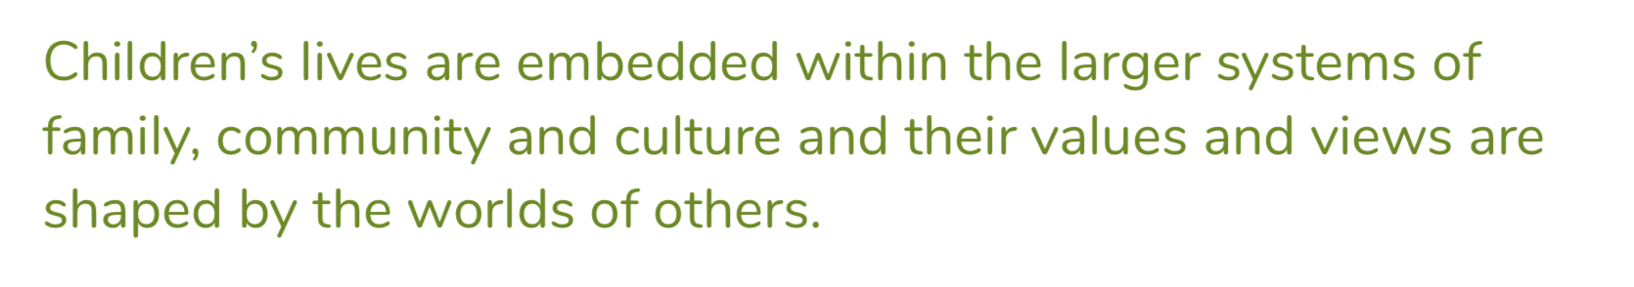
The Flourish Model - The Ecology of Wellbeing
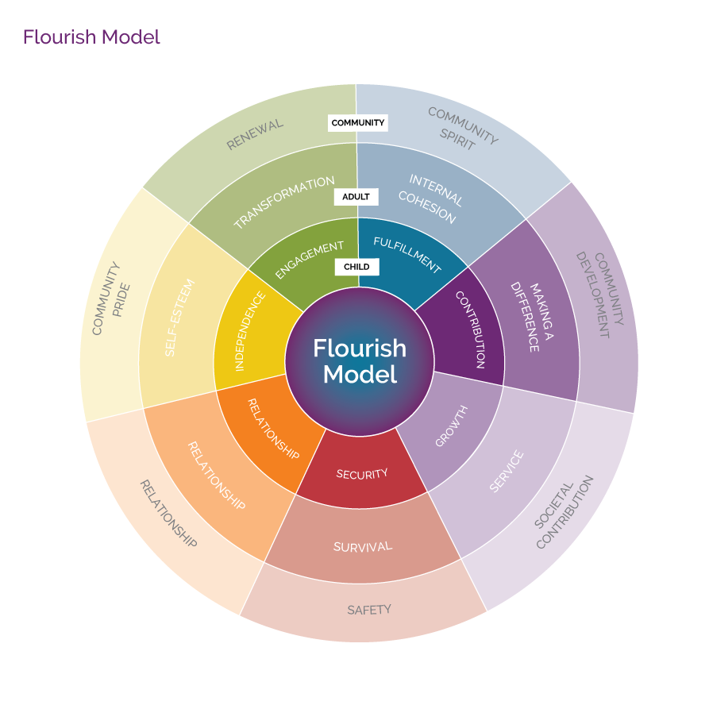
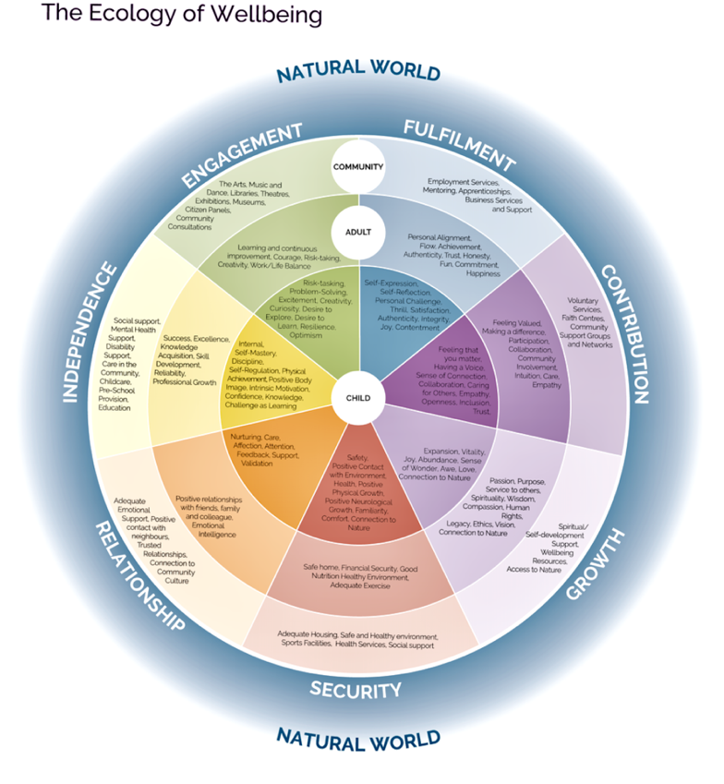
Bibliography

Kennedy, Robert, University of Kansas, March 18, 1968
United Nations Development Programme, 2018 http://hdr.undp.org/en/humandev/
Gough, I. and McGregor, J.A. eds. (2007), Wellbeing in Developing Countries: From Theory to Research. Cambridge University Press, Cambridge.
World Bank
Sarkozy Commission (2009) Final Report of the Commission on the Measurement of Economic Performance and Social Progress, Paris
Durand, Martine (2013) 4th OECD Global Forum, New Delhi
Cajete, Gregory (2000) Native Science – Natural Laws of Interdependence, Clear Light Publishers; Reprint edition
Kamaljit K.Sanghaa Andrew Le Brocquea RobertCostanzab YvonneCadet-Jamesc (2015) Ecosystems and indigenous well-being: An integrated framework, Global Ecology and Conservation Volume 4, July 2015, Pages 197-206, Elsevier
Bressa Florentin, D.B. (2015) The Politics of Buen Vivir: Between Policies and Life. Paper to the ESRC conference on The Politics of Wellbeing, Sheffield University. UK.
Better Humans. 2017-11-30. "The Japanese Concept 'Ikigai' is a Formula for Happiness and Meaning".
Forster, Dion (2006). Identity in relationship: The ethics of ubuntu as an answer to the impasse of individual consciousness (Paper presented at the South African science and religion Forum – Published in the book The impact of knowledge systems on human development in Africa. du Toit, CW (ed.), Pretoria, Research institute for Religion and Theology (University of South Africa)
Wheatley, Margaret (2017) Who do we Choose to Be? Berrett-Hoehler Publishers inc, Oakland CA pp28.
OECD (2011a), How's Life?: Measuring well-being, OECD Publishing. Compendium of OECD Wellbeing Statistic. OECD, Paris.
OECD (2013) Proceedings: 4th World Forum on Statistics, Knowledge and Policy Measuring Well-Being for Development and Policy Making. New Delhi.
UK Office of National Statistics (2011) Measuring What Matters: National Statistician’s Reflections on the National Debate on Measuring National Well-being. ONS: Newport.
Layard, Richard (2005) Happiness: Lessons from a New Science, Penguin Press, HC
UK Parliament APPG (2015) Mindful Nation Report
McGregor, A (‎2012) Bellagio Initiative, Promoting Human Wellbeing in a Challenging Global Context
United Nations (2012) World Happiness Report
Seligman, M (2013): Building the state of Wellbeing : a strategy for South Australia, Adelaide, SA Department of the Premier and Cabinet
South Australia (2016) State of Wellbeing Final Report
Seligman, Martin (2011) Flourish: A Visionary New Understanding of Happiness and Well-being. New York: Free Press
Oxfam (2012) Humankind Index
Jacob Foundation (2013) Children’s World Survey
Skoll Foundation (2018) http://www.socialprogressindex.com
Legatum Institute (2014) Commission on Wellbeing and Policy – Final Report
Children’s Trust (2006) Good Childhood Report
Children’s Society (2017) Good Childhood Report
Belconnen. McGregor (2015) Global Initiatives in Measuring Human Wellbeing: Convergence and Difference.
Barrett, Richard (2017) Everything I have ever learned about Values, Barrett Vales Centre
National Academy of Sciences (2015) Transforming the Workforce for Children Birth Through Age 8: A Unifying Foundation. Chapter 3: The Interaction of Biology and the Environment
2. Human Early Learning Partnership (2013) What makes a difference for early child development?,
Gough and McGregor (eds) Wellbeing in Developing Countries. Cambridge University Press, Cambridge.
NRC and IOM, (2000) From Neurons to Neighborhoods: The Science of Early Childhood Development
4. Louv, R (2005). Last Child in the Woods
3. Barrows, A (1995). The Ecopsychology of Child Development, in T. Roszak, M.E. Gomes & A.D. Kanner (Eds) Ecopsychology: restoring the Earth, healing the mind. New York: Sierra Press
Schultz, P. Wesley, Shriver, Chris, Tabanico, Jennifer J. & Khazian, Azar M. (2004) Implicit connections with nature. Journal of Environmental Psychology, 24(1), 31-42
Harvard Centre on the Developing Child (2017) Five Numbers to Remember about Early Childhood Development
2. Bessel A. van der Kolk, The Body Keeps the Score: Brain, Mind, and Body in the Healing of Trauma
8. Washington University (2013) The Effects of Poverty on Childhood Brain Development -The Mediating Effect of Caregiving and Stressful Life Events
Society for Psychophysiological Research (2015) Neurocognitive development in socioeconomic context
Discovery Society Policy Briefing (2014): The Biologisation of Poverty, Policy and Practice in Early Years Intervention,
Heckman, James https://heckmanequation.org
Wave Trust (2013) Conception to age 2 – the age of opportunity, Appendix 4
Conti G, Morris S, Melnychuk M, Pizzo E (2017) The economic cost of child maltreatment in the UK, NSPCC
Xiangming Fang, Derek S. Brown Curtis Florence and James A. Mercy - The Economic Burden of Child Maltreatment in the United States And Implications for Prevention, published in Child Abuse and Neglect 2012 Feb; 36(2): 156–165.
Haggerty RJ. Child health 2000: new pediatrics in the changing environment of children’s needs in the 21st century. Pediatrics. 1995;96:804–812.
UNICEF (2017) State of the World’s Children Report

